I will be sharing all the information about which fields to be used and what to do about the basic placements cta and other things used as per the pages in the website

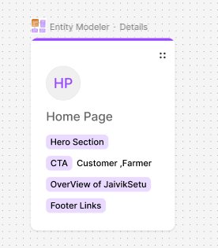

[Breadcrumb - shadcn/ui](https://ui.shadcn.com/docs/components/breadcrumb)

Home Page

Navbar:-

[21st.dev - The NPM for Design Engineers](https://21st.dev/abdulali254/nav-header/nav-header)

Hero Section :-

1)Images of ssome farms :-4 images

[21st.dev - The NPM for Design Engineers](https://21st.dev/tommyjepsen/hero-with-image-text-and-two-buttons/default)

Add Headlines

“**““Organic products to every home, a fair market to every farmer!”**

**“हर घर तक जैविक उत्पाद,  
हर किसान तक सही बाज़ार!”**

CTA

CTAs used

1) Customer

2) Farmer

Use this for the buttons

Features of the jaiviksetu

[21st.dev - The NPM for Design Engineers](https://21st.dev/aceternity/feature-section-with-card-gradient/default)

**Key Features of JaivikSetu 🌱🚀**

✅ **🔗 Direct Farmer-to-Consumer Connection**  
Buy directly from **verified organic farmers**, ensuring **fresh, chemical-free produce** without middlemen.

✅ **📜 QR Code-Based Product Traceability**  
Scan QR codes to verify **farm details, organic certification, and farming methods** before purchasing.

✅ **⚖️ Fair & Transparent Pricing**  
Farmers **set their own prices**, ensuring **fair earnings** while consumers get **affordable organic food**.

✅ **🚚 Smart Delivery System**  
Instant deliveries for **nearby farms** via **Blinkit, Dunzo** & nationwide shipping via **DHL, Delhivery**.

✅ **🛡️ Certified Organic Marketplace**  
Only **genuine, certified organic farmers** can list their products, ensuring **authenticity and trust**.

✅ **💰 Secure Payments & Easy Transactions**  
Multiple payment options (**UPI, Bank Transfer, Wallets, COD**) with **real-time order tracking**.

(Add whichever you want )

Foooootttterrrr

[21st.dev - The NPM for Design Engineers](https://21st.dev/arihantcodes/footer-section/default)

_____________________________________________________________

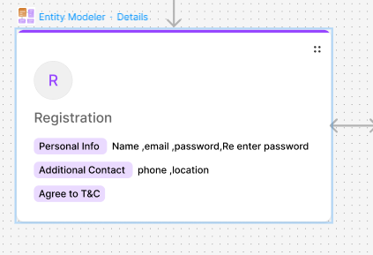

Registration

(please use whichever type of the template you want )

User name

Email

Password

Reenter Password

Phone Location

Terms and condition checkbox

Signup

Login

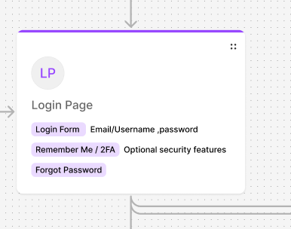

[21st.dev - The NPM for Design Engineers](https://21st.dev/originui/dialog/sign-in-dialog)

Farmer Dashboard

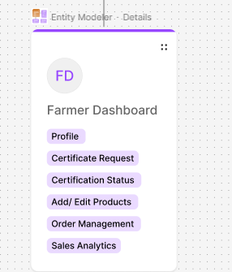

1)Profile

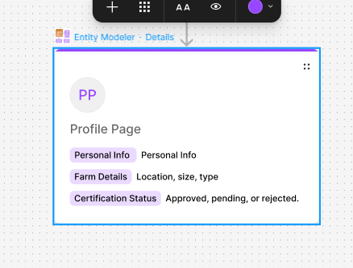

Add Side navbar

[Avatar - shadcn/ui](https://ui.shadcn.com/docs/components/avatar)

Sales Analytics

Crops List

Stock

Certificate Status (Approved,Rejected,Processing)

Certification Request Page

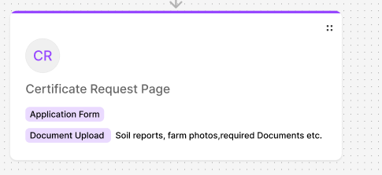

Application Form

Farmer Name

Farm Address

Village/Town/City

State

Contact Number(+91 XXXX XXXX)

Email Address

Crop Grown

Documents Tree(Adhar Card(compulsory), Farm Photos (fields, composting, organic inputs)(anything else you want to add.)(Don’t forget the file limit)

[21st.dev - The NPM for Design Engineers](https://21st.dev/originui/input/file-input)

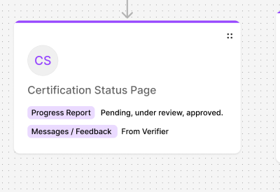

(whichever you feel like needed template)

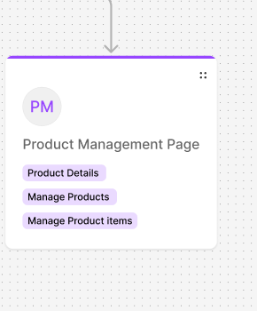

[Card - shadcn/ui](https://ui.shadcn.com/docs/components/card)

[Pagination - shadcn/ui](https://ui.shadcn.com/docs/components/pagination)

[Button - shadcn/ui](https://ui.shadcn.com/docs/components/button)

For a page that displays a **list of products**, where clicking on a product shows more details (similar to Amazon's product listing), you will need the following **ShadCN UI components**:

**Required Components:**

1. **Card** - To display each product in the list.
2. **Avatar (Optional)** - If you want to show an icon or image for the product.
3. **Typography (Heading, Text, Muted)** - For product name, description, and details.
4. **Button / Link** - To allow users to navigate to the product details page.
5. **Grid / Flexbox (CSS/Tailwind)** - To arrange multiple products in a list/grid format.
6. **Modal (Optional)** - If you want to show product details in a pop-up instead of navigating to another page.
7. **Dropdown Menu (Optional)** - If you want additional options (like Add to Cart, Wishlist, etc.).
8. **Badge (Optional)** - To show product status (e.g., "New," "Discounted").

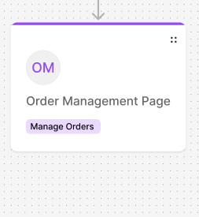

For an **Order Management Page** where users can manage their orders (similar to "My Orders" in Amazon), you will need the following **ShadCN UI components**:

**Required Components:**

1. **Card** - To display each order's summary.

[Card - shadcn/ui](https://ui.shadcn.com/docs/components/card)

1. **Table** - To list multiple orders with details like Order ID, Status, Date, and Total.

[Data Table - shadcn/ui](https://ui.shadcn.com/docs/components/data-table)

1. **Badge** - To show order status (e.g., "Shipped," "Delivered," "Pending").

[Badge - shadcn/ui](https://ui.shadcn.com/docs/components/badge)

1. **Button** - For actions like "View Details," "Track Order," or "Cancel Order."
2. **Dropdown Menu** - To provide additional options for each order (e.g., "Return," "Download Invoice").

[Dropdown Menu - shadcn/ui](https://ui.shadcn.com/docs/components/dropdown-menu)

1. **Separator** - To visually organize order sections.

[Separator - shadcn/ui](https://ui.shadcn.com/docs/components/separator)

1. **Modal (Optional)** - To show detailed order information in a pop-up.
2. **Tabs (Optional)** - To separate orders by status (e.g., "Active Orders," "Completed Orders," "Cancelled Orders").

[Tabs - shadcn/ui](https://ui.shadcn.com/docs/components/tabs)

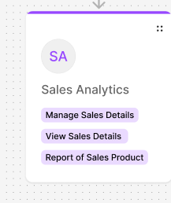

For a **Sales Analytics Page**, where you track sales performance and trends, you will need the following **ShadCN UI components**:

**Required Components for Sales Analytics Dashboard**

1. **Card** - To display key sales metrics (e.g., Total Sales, Revenue, Orders, Profit).
2. **Table** - To list recent transactions, top-selling products, or sales data.
3. **Charts (Using Recharts or Any Chart Library)** - For sales trends, revenue growth, or category performance.
4. **Tabs (Optional)** - To switch between different views (e.g., "Daily," "Monthly," "Yearly").
5. **Dropdown Menu** - For filters (e.g., "Sort by Date," "Filter by Product Category").
6. **Badge** - To indicate trends (e.g., "Up 10%," "Down 5%").
7. **Separator** - To keep sections visually organized.
8. **Button** - For exporting data (e.g., "Download Report").
9. **Modal (Optional)** - To show detailed insights on specific sales data.
10. **Input + Date Picker (Optional)** - To select a date range for analytics.

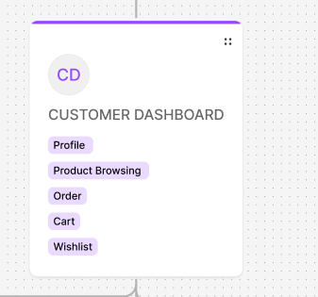

For a **Customer Dashboard**, where users can manage their profile, orders, and interactions, you will need the following **ShadCN UI components**:

**Required Components for Customer Dashboard**

1. **Card** - To display key customer details and sections.
2. **Avatar** - For profile picture or initials.
3. **Typography (Heading, Text, Muted)** - For customer name, email, and other info.
4. **Tabs** - To switch between sections (e.g., "Profile," "Orders," "Wishlist," "Settings").
5. **Table** - To list order history, saved items, or transaction records.
6. **Badge** - To indicate order status (e.g., "Pending," "Delivered").
7. **Button** - For actions like "Edit Profile," "Track Order," "Logout."
8. **Dropdown Menu** - For quick access to settings or preferences.
9. **Separator** - To organize sections clearly.
10. **Modal (Optional)** - To edit profile or view order details without leaving the page.
11. **Input + Form (Optional)** - To allow users to update profile details or change passwords.

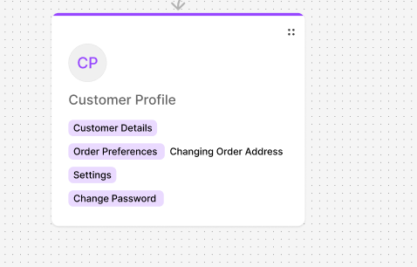

**Required Components for Customer Profile Page**

1. **Card** - To display profile information in a structured way.
2. **Avatar** - For profile picture or initials.
3. **Typography (Heading, Text, Muted)** - For displaying user name, email, and other details.
4. **Form + Input Fields** - To allow users to edit their name, email, phone, and address.
5. **Button** - For actions like "Edit Profile," "Save Changes," or "Change Password."
6. **Tabs (Optional)** - To navigate between sections like "Personal Info," "Security," and "Preferences."
7. **Dropdown Menu (Optional)** - For selecting options like notification preferences.
8. **Separator** - To organize different sections clearly.
9. **Badge (Optional)** - To indicate user status (e.g., "Verified," "Premium User").
10. **Modal (Optional)** - To update profile picture or change password without navigating away.

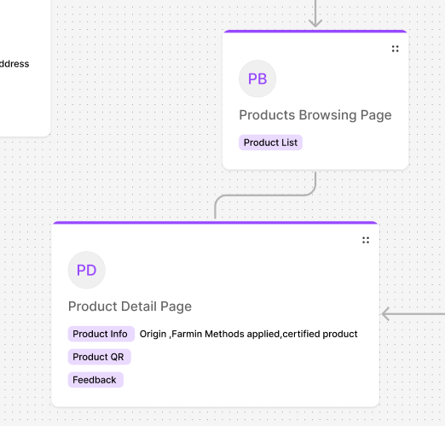

## **📌 Product Browsing Page** (Product Listing)

A page where users can browse multiple products.

### ****Required Components:****

1. **Card** - To display each product with an image, name, and price.
2. **Grid/Flexbox (CSS/Tailwind)** - To arrange products in a grid or list format.
3. **Image** - For product thumbnails.
4. **Typography (Heading, Text, Muted)** - To show product name, description, and price.
5. **Badge** - To indicate discounts, new arrivals, or bestsellers.
6. **Button** - For "Add to Cart," "Buy Now," or "View Details."
7. **Dropdown Menu** - To filter/sort products (e.g., Price Low to High, Most Popular).
8. **Pagination** - To navigate between product pages.
9. **Search Input** - For searching products by name or category.
10. **Sidebar (Optional)** - For product filters (e.g., price range, category).

## **📌 Product Detail Page**

A page showing full details when a user clicks on a product.

### ****Required Components:****

1. **Card** - To display product details inside a structured layout.
2. **Image Carousel/Viewer** - To showcase multiple product images.
3. **Typography (Heading, Text, Muted)** - For product name, description, price, and specifications.
4. **Badge** - To highlight discounts, stock status, or bestseller tags.
5. **Button** - For "Add to Cart," "Buy Now," "Wishlist."
6. **Tabs** - To switch between sections like "Description," "Reviews," "Specifications."
7. **Table (Optional)** - For detailed specifications.
8. **Accordion (Optional)** - To expand FAQs or additional product details.
9. **Review Section** - With user ratings and comments.
10. **Related Products Section** - To recommend similar items.

### ****🚀 Do you want a React code snippet for these pages?****

